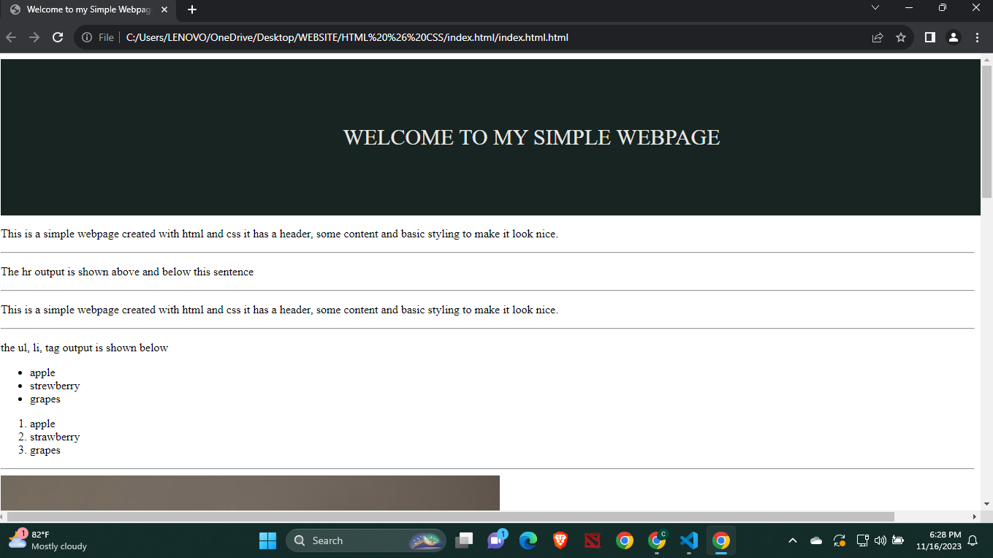NAME: CHRISTIAN DAVE E. POMBO BSIT 1B SECTION CODE: IT111  
  
  
ACTIVITY: BASIC HTML & CSS  
  
  
  
  
  
  
  
  
  
  
  
  
  
  
  
  
  
  
  
  
  
  
  
  
  
  
  
  
  
  
  
  
  
  
  
  
  
  
  
  
  
  
  
  
  
  
  
  
  
